

**TIS1101 – Database Fundamentals**

**Group Project: Part 2**

**Airline Reservation System**

Group Members (TC01 | TT02):

1. Samuel Wong (1151103687)
2. Wayile Jialade (1151102347)

Contents

Business Rules: 3

Entity Relationship Diagram: 4

Data Dictionary 5

Data Definition Language (DDL): 7

Creating the database 7

Connecting to the database 7

Create tables 7

LIST TABLES 9

Data Insertion: 10

Contact Table 10

Aircraft Table 12

Fare Table 14

Passenger Table 16

Flight Table 17

Book Table 19

Data Manipulation Language (DML): 21

Triggers: 21

Stored Procedure: 24

Aggregate function : 28

Query with a Group by and Having clauses: 30

Query with a Subquery: 31

Queries that are not covered in lecture: 32

# Business Rules:

1. All passengers have to submit their names, contact details, gender and passport no.

2. All passengers can access their flight details such as flight date, departure time, arrival time, starting location, arrival location, duration of flight and aircraft details.

3. All passengers have to pay for their flight tickets which depend on the original price and the discount rate if there is any.

4. All passengers have to provide their emails, cell phone numbers and telephone numbers as their contact details.

5. Flight details will include aircraft details such as aircraft model and aircraft manufacturer.

6. All details for the booking of a flight will be displayed on the ticket and will include all information about the passenger, flight and fares.

7. Arrival times for all available flights will be before 11:59pm of any given day and departure times for all available flights will be after 12:01am of any given day.

8. The company will provide free gifts for the first 3 passengers of all flights.

# Entity Relationship Diagram:

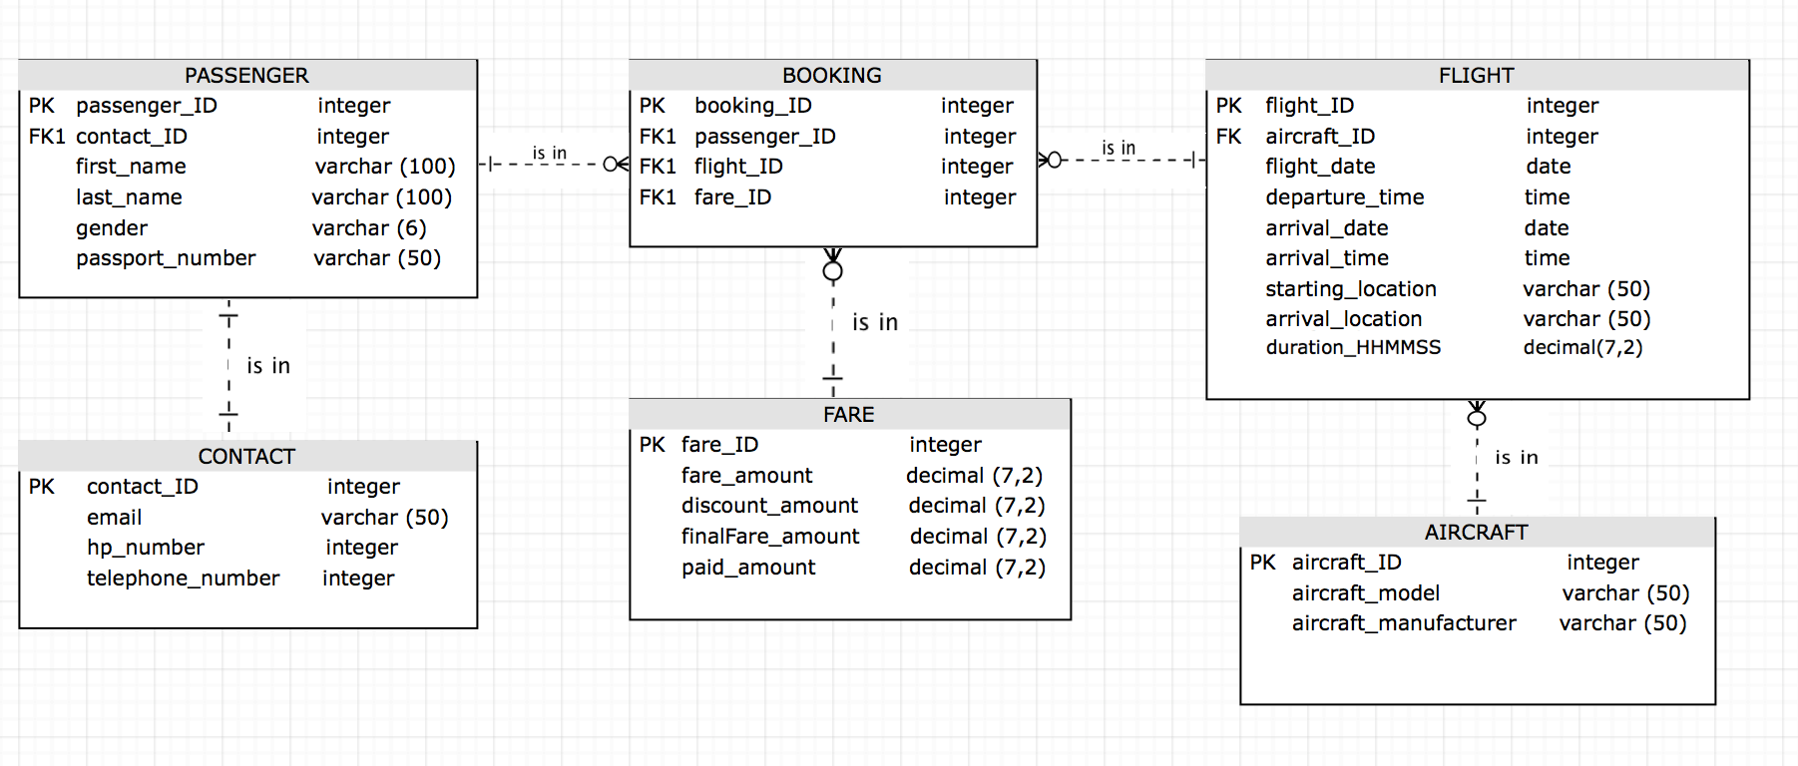

# Data Dictionary

# Data Definition Language (DDL):

## Creating the database

CREATE DATABASE Airline

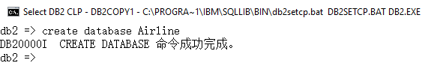

## Connecting to the database

CONNECT TO Airline

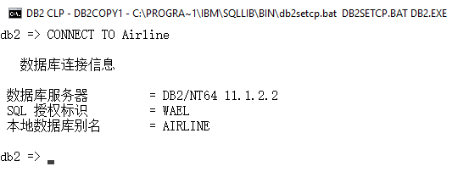

## Create tables

create table Contact (contact_ID int not null primary key, email varchar(50), hp_number int, telephone_number int) ;

select * from Contact

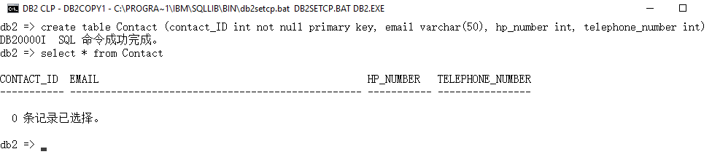

create table Aircraft (aircraft_ID int not null primary key, aircraft_model varchar(50), aircraft_manufacturer varchar(50)) ;

select * from Aircraft

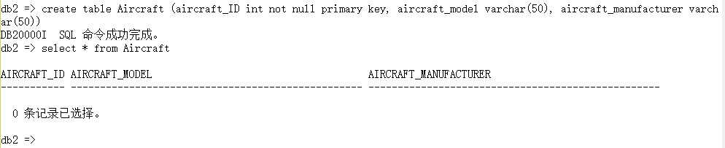

create table Fare (fare_ID int not null primary key, fare_amount decimal(7,2), discount_amount decimal(7,2), finalFare_amount decimal(7,2), paid_amount decimal(7,2)) ;

select * from Fare

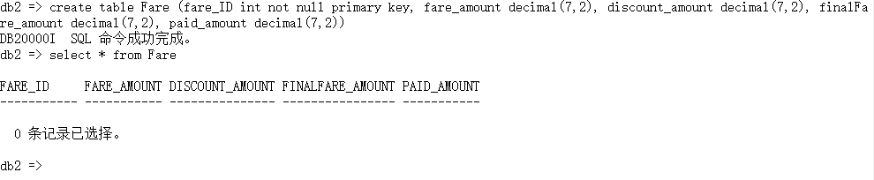

create table Passenger (passenger_ID int not null primary key, first_name varchar(100), last_name varchar(100), contact_ID int, gender varchar(6), passport_Number varchar(50), foreign key (contact_ID) references Contact) ;

select * from Passenger

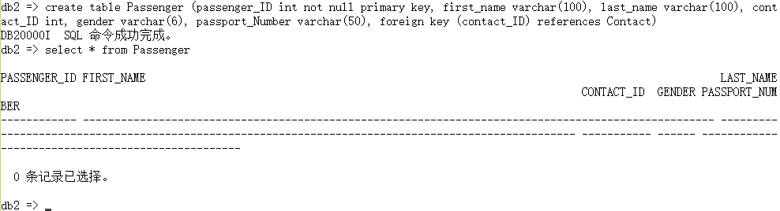

create table Flight (flight_ID int not null primary key, flight_date date, departure_time TIME, arrival_date date, arrival_time TIME, starting_location varchar(50), location varchar(50), duration_HHMMSS decimal(7,2) , aircraft_ID int, foreign key (aircraft_ID) references Aircraft) ;

select * from Flight

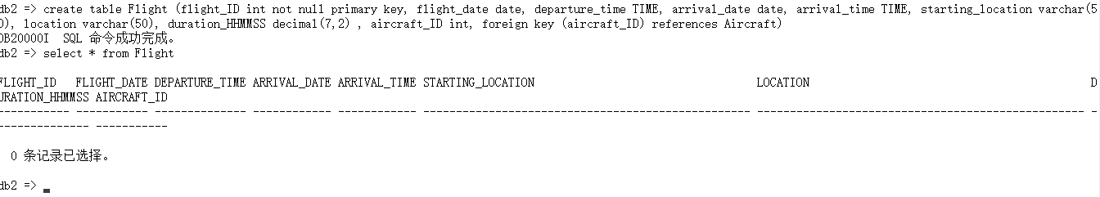

create table Booking (booking_ID int not null primary key, passenger_ID int, flight_ID int, fare_ID int, foreign key (passenger_ID) references Passenger, foreign key (flight_ID) references Flight, foreign key (fare_ID) references Fare) ;

select * from Booking

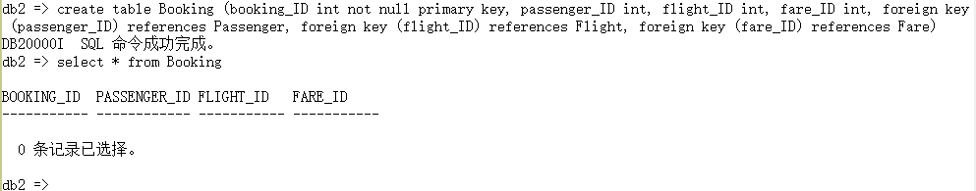

## LIST TABLES

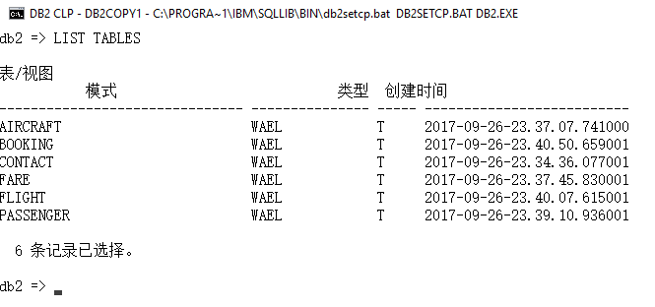

# Data Insertion:

## Contact Table

insert into Contact values (001, 'theguy007@gmail.com', 0123345599, 083454992)

insert into Contact values (002, 'batmanfly@gmail.com', 0155240279, 083773977)

insert into Contact values (003, 'geargod@gmail.com', 0111045319, 083599954)

insert into Contact values (004, 'chessit87@gmail.com', 0111045319, 083599954)

insert into Contact values (005, 'whatsupbro@gmail.com', 0141065619, 076589364)

insert into Contact values (006, 'wrty1290y@gmail.com', 013457890, 090657487)

insert into Contact values (007, 'uighurbty9@gmail.com', 0141065619, 076589364)

insert into Contact values (008, 'theglugy765@gmail.com', 012178649, 077656677)

insert into Contact values (009, 'chromebastr@gmail.com', 0141065619, 09657833)

insert into Contact values (010, 'qq456784@gmail.com', 013490876, 0890652890)

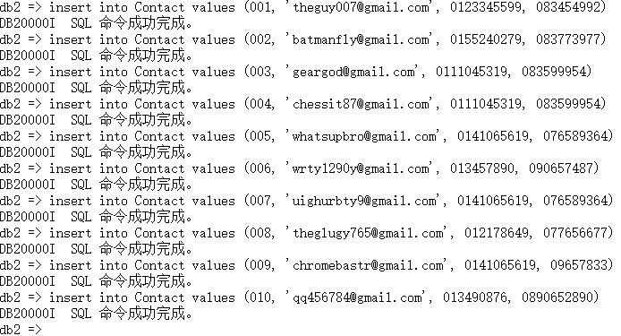

select * from Contact

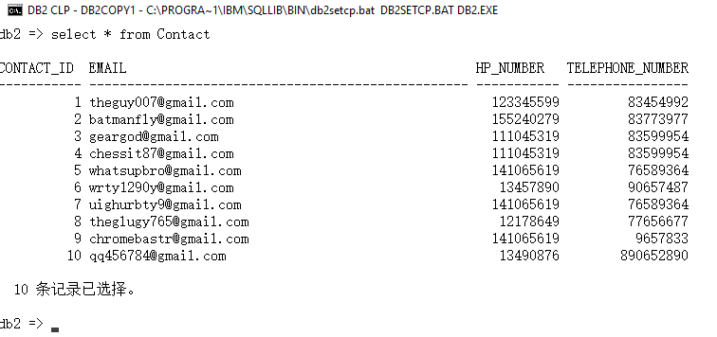

## Aircraft Table

insert into Aircraft values (1001, 'A380F', 'Airbus')

insert into Aircraft values (1002, '747-100', 'Boeing')

insert into Aircraft values (1003, 'C105', 'Dot')

insert into Aircraft values (1004, 'A380F', 'Airbus')

insert into Aircraft values (1005, '737-100', 'Boeing')

insert into Aircraft values (1006, 'C105', 'Dot')

insert into Aircraft values (1007, ' A380F ', 'Airbus')

insert into Aircraft values (1008, '747-100', 'Boeing')

insert into Aircraft values (1009, 'C105', 'Dot')

insert into Aircraft values (1010, ' A320-100 ', 'Airbus')

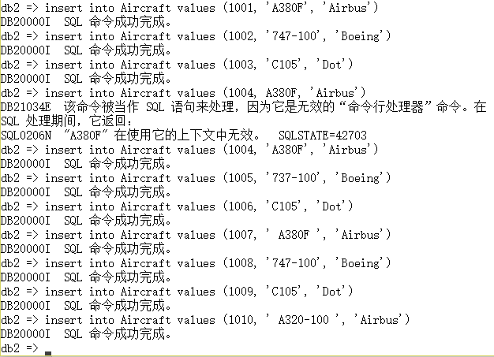



select * from Aircraft

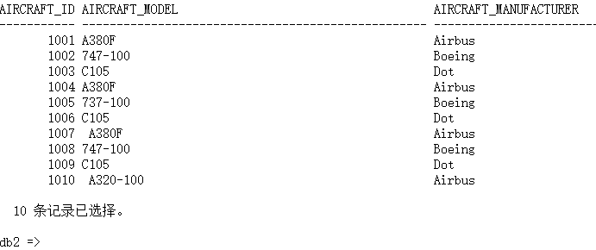

## Fare Table

insert into Fare values (12001, 350.00, 15.00, 335.00, 335.00)

insert into Fare values ( 12002, 750.00, 35.00, 715.00, 715.00)

insert into Fare values ( 12003, 800.00, 35.00, 765.00, 765.00)

insert into Fare values ( 12004, 850.00, 400.00, 435.00, 435.00)

insert into Fare values ( 12005, 900.00, 135.00, 765.00, 765.00)

insert into Fare values ( 12006, 950.00, 385.00, 565.00, 565.00)

insert into Fare values ( 12007, 1000.00, 875.00, 125.00, 125.00)

insert into Fare values ( 12008, 1050.00, 135.00, 915.00, 915.00)

insert into Fare values ( 12009, 1100.00, 225.00, 875.00, 875.00)

insert into Fare values ( 12010, 1150.00, 485.00, 665.00, 665.00)

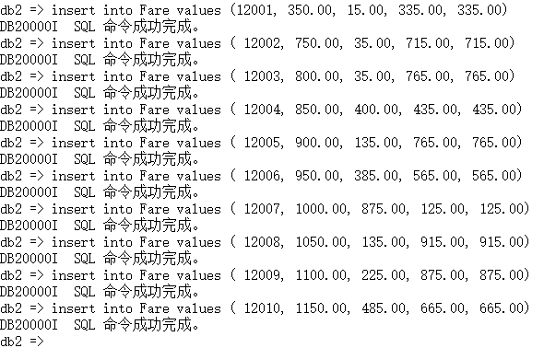

select * from Fare

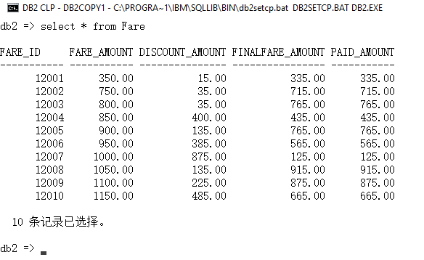

## Passenger Table

insert into Passenger values (17082101, 'John', 'Harry', 001, 'Male', 'A0075551202')

insert into Passenger values (17082102, 'Mary', 'Swift', 002, 'Female', 'A0062351230')

insert into Passenger values (17082103, 'Timothy', 'Jonathan', 003, 'Male', 'A0062923745')

insert into Passenger values (17082104, 'Tom', 'Galydo', 004, 'Male', 'A0062675432')

insert into Passenger values (17082105, 'Lucy', 'Hong', 005, 'Female', 'A006251389')

insert into Passenger values (17082106, 'Peter', 'Caiswa', 006, 'Male', 'A005678945')

insert into Passenger values (17082107, 'Lily', 'Mayer', 007, 'Female', 'A00458763')

insert into Passenger values (17082108, 'Hansen', 'Loh', 008, 'Male', 'A004560987')

insert into Passenger values (17082109, 'Catherine', 'Florida', 009, 'Female', 'A004567894')

insert into Passenger values (17082110, 'Gray', 'Snake', 010, 'Male', 'A003567964')

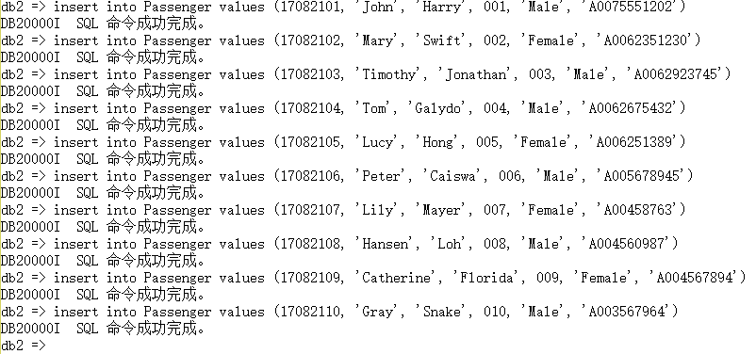

select * from Passenger

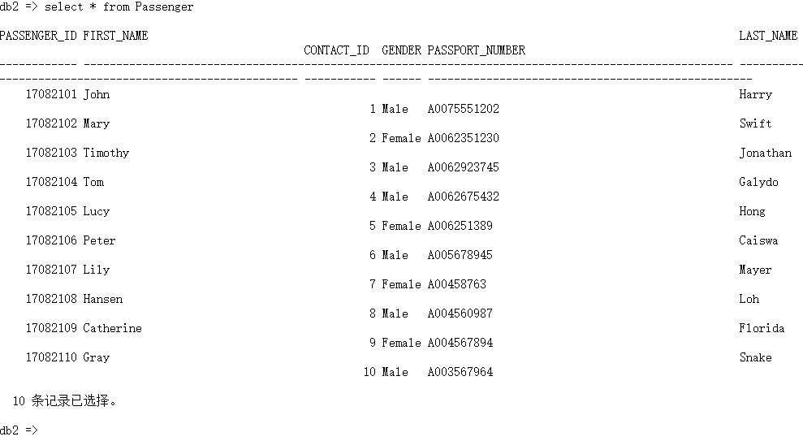

## Flight Table

insert into Flight values (35001, '2017-02-15','09:30:25',’2017-02-15’,'11:30:25', 'Kuala Lumpur', 'Kuching', 0.00, 1001 )

insert into Flight values (35002, '2017-02-17','10:35:27',’2017-02-27’,'13:35:25', 'Kota Kinabalu', 'Kuala Lumpur', 0.00, 1002 )

insert into Flight values (35003, '2017-02-19','07:40:45',’2017-02-19’,'9:30:25', 'Bintulu', 'Alor Setar', 0.00, 1003 )

insert into Flight values (35004, '2017-02-21','06:30:25',’2017-02-15’,'11:30:25', 'Melaka', 'Kuching', 0.00, 1004 )

insert into Flight values (35005, '2017-02-23','05:45:25',’2017-02-23’,'11:45:25', 'Johor Bahru', 'Pulau Pinang', 0.00, 1005 )

insert into Flight values (35006, '2017-02-25','09:30:25',’2017-02-25’,'14:30:25', 'Sibu', 'Singapore', 0.00, 1006 )

insert into Flight values (35007, '2017-02-15','11:45:00',’2017-02-15’,'15:30:00', 'Singapore', 'Alor Setar', 0.00, 1007 )

insert into Flight values (35008, '2017-02-15','13:56:00',’2017-02-15’,'16:30:25', 'London', 'Kuching', 0.00, 1008 )

insert into Flight values (35009, '2017-02-25','11:30:25',’2017-02-25’,'17:30:25', 'Kuala Lumpur', 'New York', 0.00, 1009 )

insert into Flight values (35010, '2017-02-15','09:30:25',’2017-02-15’,'11:30:25', 'Los Angeles', 'Kuching', 0.00, 1010 )

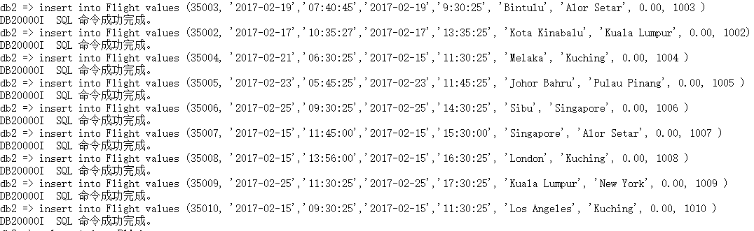

select * from Flight

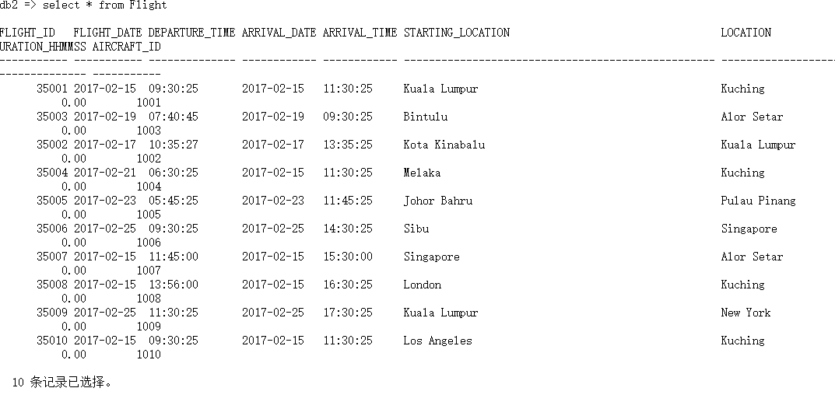

## Book Table

insert into Booking values (18001010, 17082101, 35001, 12001)

insert into Booking values (18001011, 17082102, 35002, 12002)

insert into Booking values (18001012, 17082103, 35003, 12003)

insert into Booking values (18001013, 17082104, 35004, 12004)

insert into Booking values (18001014, 17082105, 35005, 12005)

insert into Booking values (18001015, 17082106, 35006, 12006)

insert into Booking values (18001016, 17082107, 35007, 12007)

insert into Booking values (18001017, 17082108, 35008, 12008)

insert into Booking values (18001018, 17082109, 35009, 12009)

insert into Booking values (18001019, 17082110, 35010, 12010)

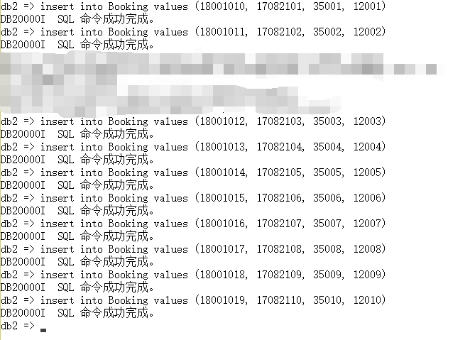

select * from Booking

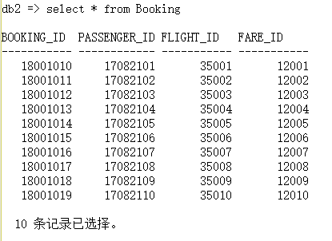

# Data Manipulation Language (DML):

## Triggers:

In the database, the Fare table includes fare_amount, discount_amount and finalFare_amount. A trigger is used to automatically update all finalFare_amount in the table according to amount and amount after every insertion of the Fare table.

create trigger Update_FinalFare after insert on Fare for each row mode db2sql update Fare set finalFare_amount = (fare_amount - discount_amount) where discount_amount > 0

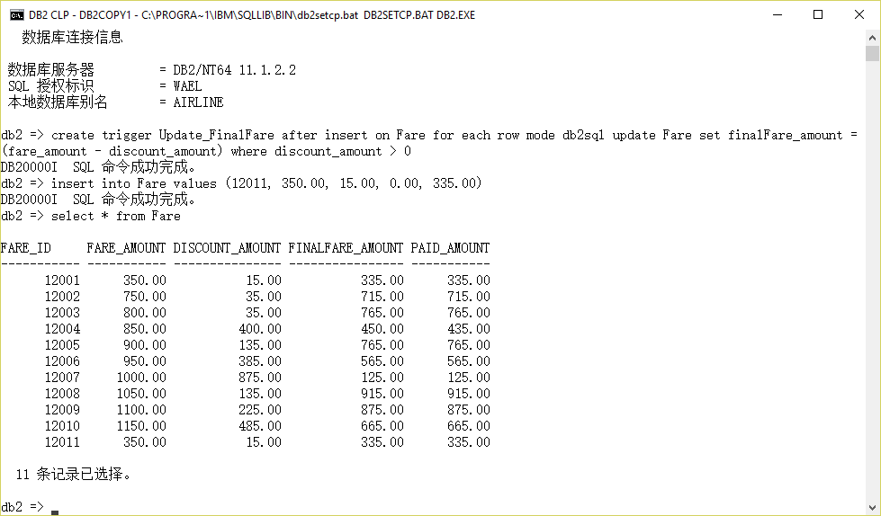

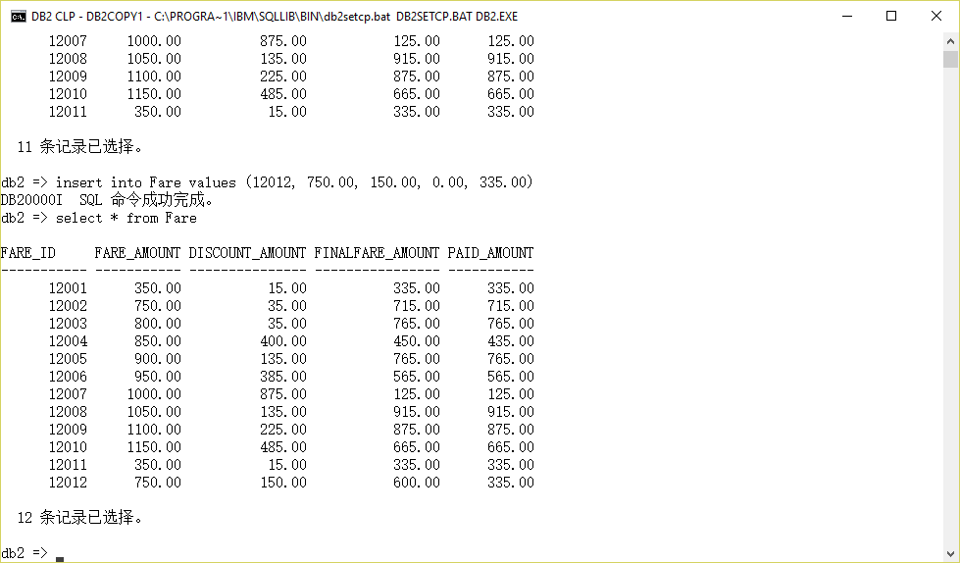

In the database, the Flight table includes departure_time, arrival_time and duration_HHMMSS. A trigger is created to automatically calculate duration_HHMMSS according to the departure_time and arrival_time every time an insertion is done on the Flight table.

create trigger Update_FlightDuration after insert on Flight for each row mode db2sql update Flight set duration_minutes = arrival_time - departure_time where exists (select arrival_time, departure_time from Flight)





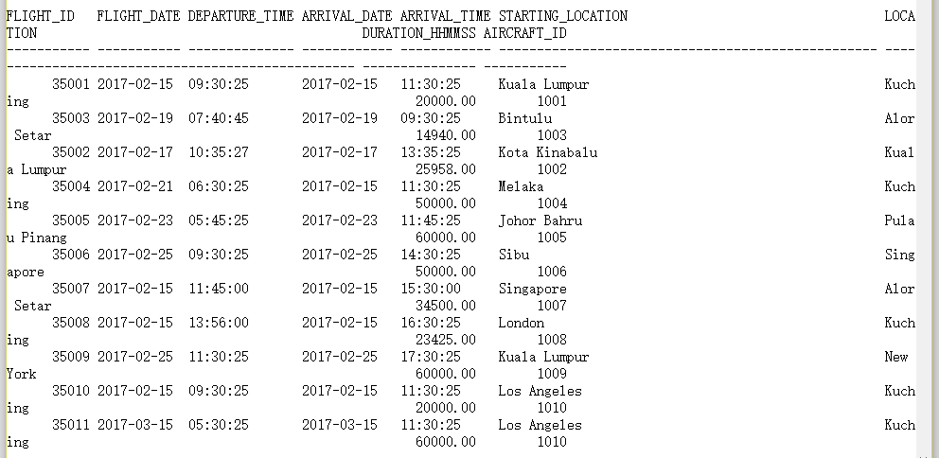

## Stored Procedure:

A stored procedure named searchFlightwithID is created to search the database on Flight table for a relevant Flight according to the provided Flight ID.

create procedure searchFlightwithID (in f_ID int) begin DECLARE c cursor with return for select * from Flight where flight_ID = f_ID; Open c; end

CALL searchFlightwithID(35001)

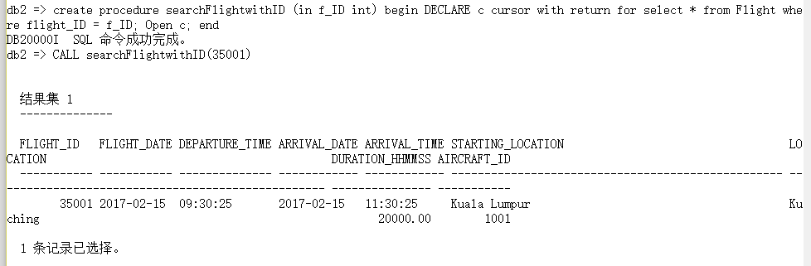

CALL searchFlightwithID(35003)

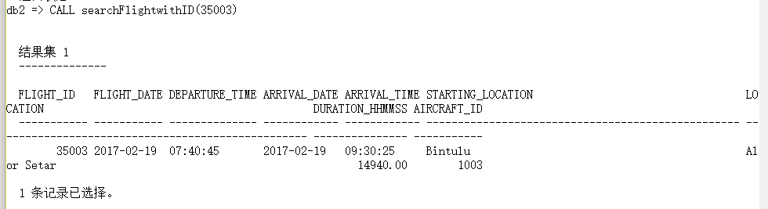

CALL searchFlightwithID(35010)

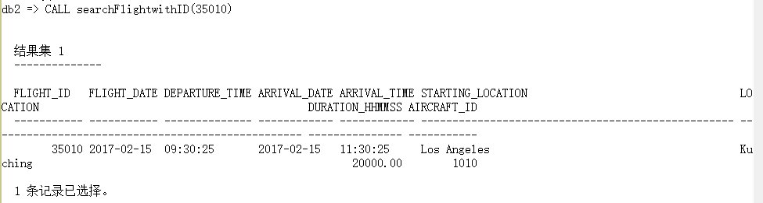

A stored procedure named countPassengerInFlights is created to count the number of passenger in a flight.

create procedure countPassengerInFlights (in flightID int) begin declare c cursor with return for select count (b.booking_ID) from Booking b where b.flight_ID = flightID ; open c ; end

call countPassengerInFlights (35001) ;

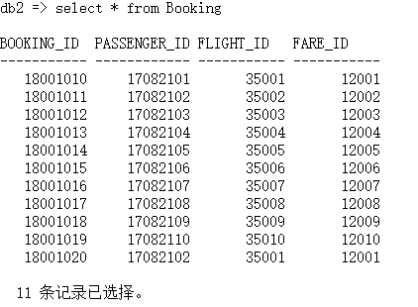

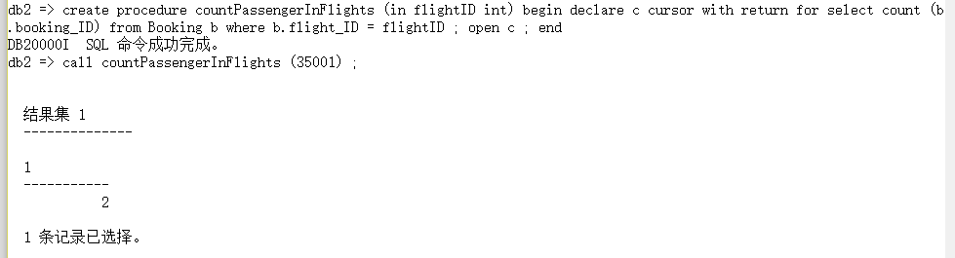

A stored procedure named first3Passengers is created to select the first 3 bookings made by passengers in a flight. This procedure can be useful when free gifts are provided for the first 3 passengers in a flight.

create procedure first3Bookings (in flightID int) begin declare c cursor with return for Select Passenger.passenger_ID, Passenger.first_name, Passenger.last_name from Passenger,Booking,Flight where Passenger.passenger_ID = Booking.passenger_ID and Booking.flight_ID = Flight.flight_ID and Flight.flight_ID = flightID FETCH FIRST 3 ROW ONLY; open c ; end

call first3Bookings (35001);

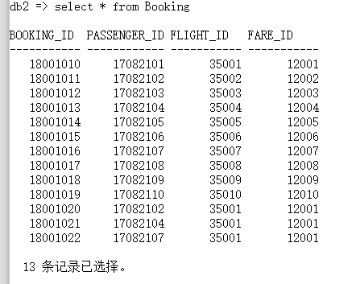



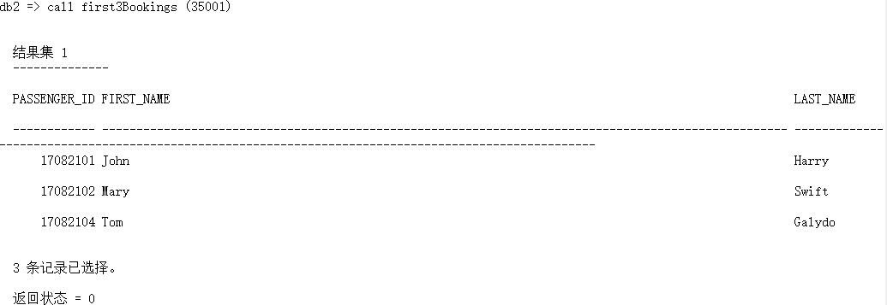

A view function named aircraftUsedOnFlights is created to display the aircraft used and other related details of all flights.

create view aircraftUsedOnFlights as select f.flight_date, f.departure_time, f.arrival_time, f.arrival_date, f.starting_location, f.location, f.duration_minutes, f.aircraft_ID, a.aircraft_model, a.aircraft_manufacturer from Flight f, Aircraft a where f.aircraft_ID = a.aircraft_ID ;

select * from aircraftUsedOnFlights ;

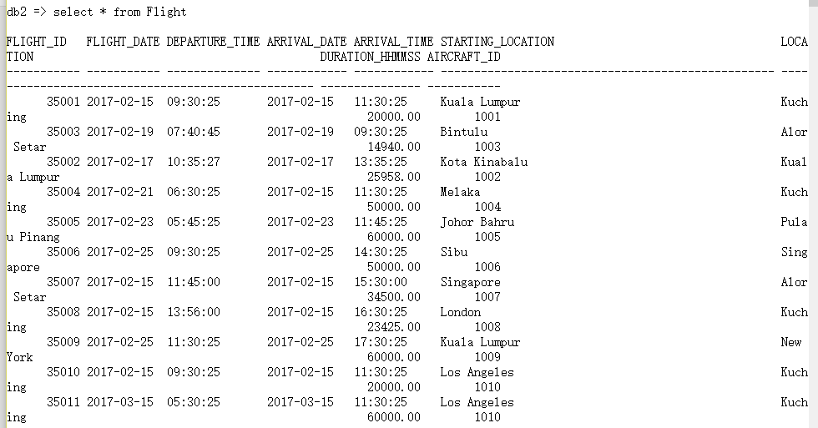

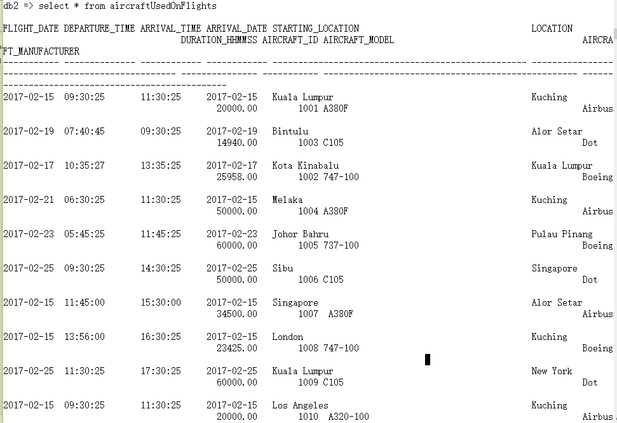

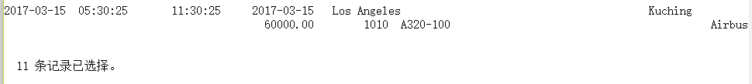

## Aggregate function :

For analysis purpose, a query is created to display the total number of passenger categorized by gender.

select count(Passenger.passenger_ID), Passenger.gender from Passenger group by gender having count(gender) > 0

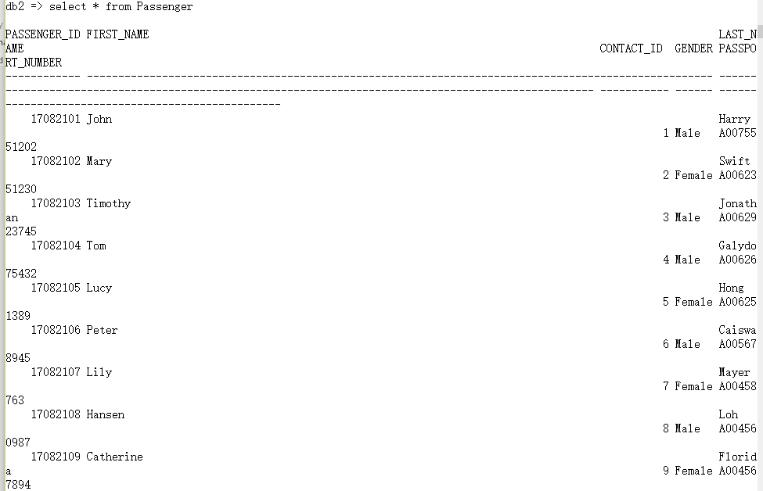

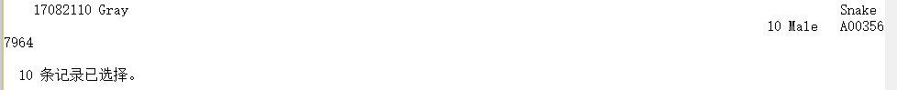

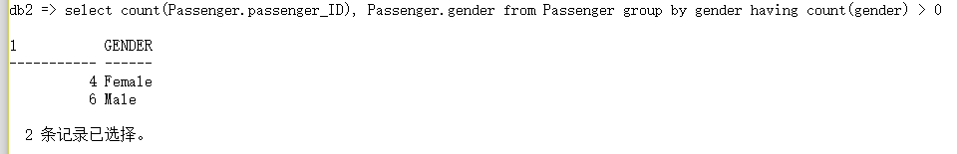

A Count function is used in the stored procedure, countPassengerInFlights to display the total number of passenger in a flight.

create procedure countPassengerInFlights (in flightID int) begin declare c cursor with return for select count (b.booking_ID) from Booking b where b.flight_ID = flightID ; open c ; end

call countPassengerInFlights (35001) ;





## Query with a Group by and Having clauses:

For analysis purpose, a query is created to display the total number of passenger categorized by gender.

select count(Passenger.passenger_ID), Passenger.gender from Passenger group by gender having count(gender) > 0







## Query with a Subquery:

In the database, the Flight table includes departure_time, arrival_time and duration_HHMMSS. A trigger is created to automatically calculate duration_HHMMSS according to the departure_time and arrival_time every time an insertion is done on the Flight table.

create trigger Update_FlightDuration after insert on Flight for each row mode db2sql update Flight set duration_minutes = arrival_time - departure_time where exists (select arrival_time, departure_time from Flight)







## Queries that are not covered in lecture:

A query to display the best contact method or information of all entries in the Contact table. For example, if mobile number is not available or null, telephone number is displayed and if both mobile number and telephone number are available, mobile number will be displayed.

select c.contact_ID, COALESCE (c.hp_number, c.telephone_number) Contact_Info from Contact c

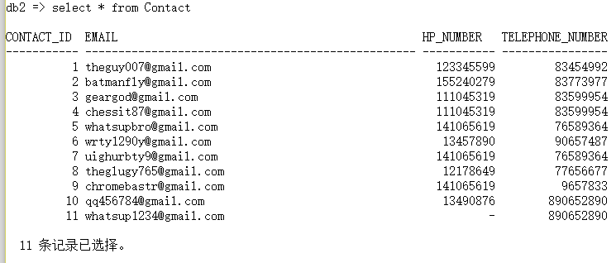

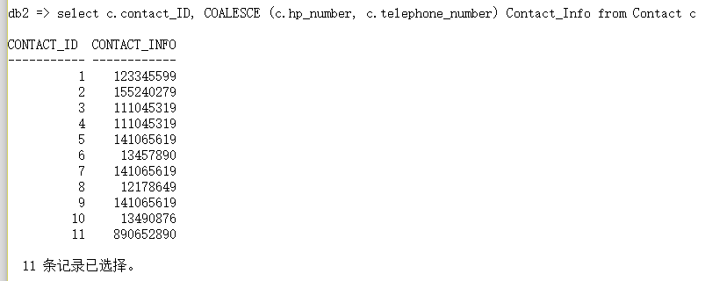

A stored procedure named first3Passengers is created to select the first 3 bookings made by passengers in a flight. This procedure can be useful when free gifts are provided for the first 3 passengers in a flight.

create procedure first3Passengers (in flightID int) begin declare c cursor with return for Select Passenger.passenger_ID, Passenger.first_name, Passenger.last_name from Passenger,Booking,Flight where Passenger.passenger_ID = Booking.passenger_ID and Booking.flight_ID = Flight.flight_ID and Flight.flight_ID = flightID FETCH FIRST 3 ROW ONLY; open c ; end

call first3Passengers (35001);





